**B 325**Microprocessor wheel balancer with LCD monitor.

Picture

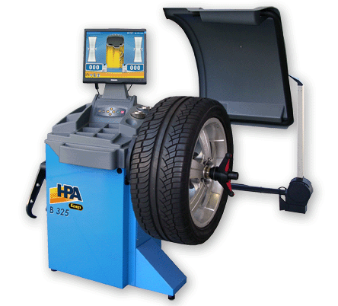

|  |
| --- |
| **Main features** |
| Microprocessor wheel balancer with self-calibration and self-diagnosis programs. |
| 19” or 17” LCD colour monitor **(Optional)** |
| User friendly keyboard. |
| Automatic start by lowering wheel guard. |
| Automatic stop at the unbalance position (RPA). |
| Low balancing speed. |
| Automatic gauge for wheel distance and diameter data input. |
| 7 programs for alloy rims: ALU std, ALU P. |
| **“Shift planes”** program (in ALU P). |
| **“Hidden weights”** program (in ALU P). |
| **“Weight division”** program (bike programs). |
| Wheel guard **included**. |
| Automatic gauge for wheel width measuring (optional). |
| Front support base for balancing wheels up to 50 kg. without fastening the machine to the ground (optional). |
|  |
| **Technical data** |
| Power supply................................................................................................................100/230 V - 1 Ph - 50/60 Hz |
| Overall power draw......................................................................................................................................100 W |
| Shaft diameter............................................................................................................................................40 mm |
| Noise level when running.......................................................................................................................< 70 dB (A) |
| Weight with guard (without accessories...........................................................................................................82 kg |
| **Working parameters:** |
| Average measuring time ..................................................................................................................................7 s |
| Rim width...............................................................................................................................................1.5"÷20" |
| Rim diameter............................................................................................................................................10"÷28" |
| Max. wheel weight (with ground fastening).................................................................................................... 75 kg |
| Maximum wheel/machine distance ............................................................................................................ 275 mm |
| Max. wheel width (with guard)...................................................................................................................600 mm |
| Max. wheel diameter (with guard)............................................................................................................1117 mm |
| Readout accuracy............................................................................................................................................1 g |
| Maximum unbalance value calculated............................................................................................................ 999 g |
| Balancing speed...............................................................................................................................90÷130 r.p.m. |
|  |
|  |
| **Supplied accessories** |
| Base universal self-centering 3 cones |
| Rim width caliper |
| Threaded hb and extractor |
| SLUG calibration sample weight |
|  |
|  |
| **Optional accessories** |
| A wide range of accessories to meet all balancing needs are available. |

Brochure